*#Exp No : 7*

*# Aim:To perform data visualization on given data set using Matplotlib.*

*# Name : Samruddhi M. Umap # Roll no : 67*

*# Sec:C*

*# Subject : Data Science*

a=20 b=30

c=a+b c

50

a=(1,2,3,"Samruddhi",2.3,True) type(a)

tuple len(a) 6 a[1::1]

(2, 3, 'Samruddhi', 2.3, True)

b=[1,2,3,"Samruddhi",2.3,True] type(b)

list len(b) 6

import numpy as np

from matplotlib import pyplot as plt a[0]

1

x=np.arange(1,11) x

array([ 1, 2, 3, 4, 5, 6, 7, 8, 9, 10])

y=2\*x y

array([ 2, 4, 6, 8, 10, 12, 14, 16, 18, 20])

plt.plot(x,y) plt.show

<function matplotlib.pyplot.show(close=None, block=None)>

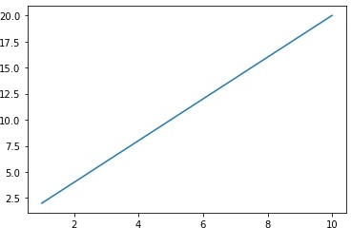

plt.plot(x,y) plt.title("Line Chart") plt.xlabel("X axis") plt.ylabel("Y axis") plt.show

<function matplotlib.pyplot.show(close=None, block=None)>

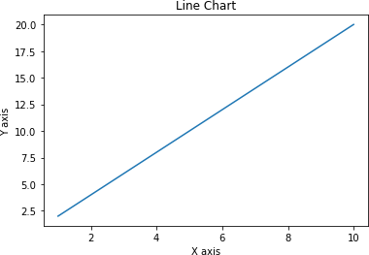

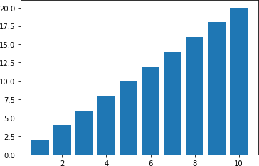

plt.bar(x,y) plt.show

<function matplotlib.pyplot.show(close=None, block=None)>

plt.bar(x,y) plt.title("Bar Chart") plt.xlabel("X axis")

Text(0.5, 0, 'X axis')

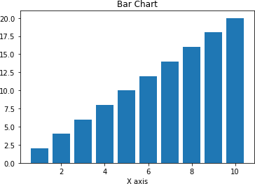

plt.ylabel("Y axis") plt.show

<function matplotlib.pyplot.show(close=None, block=None)>

